Full Stack Development with MERN Project Documentation

1. Introduction

Project Title: Book A Doctor

Team Member: M. Madhavi

2. Project Overview
Purpose:
The Book A Doctor application is a MERN stack web application developed to simplify the process of booking doctor appointments online. It enables patients to register, log in, view doctors, and book appointments efficiently.

Features:
- User Registration and Login
- Doctor Login and Dashboard
- Book Appointments
- View Appointment Details
- Secure Authentication
- Responsive User Interface

3.Architecture

Frontend: React.js with Material UI for creating a responsive user interface.

Backend: Node.js and Express.js are used to develop RESTful APIs.

Database: MongoDB stores user, doctor, and appointment data.

4. Setup Instructions

Prerequisites:

- Node.js
- MongoDB
- npm

Installation:

1. Clone the project.
2. Install dependencies using "npm install".
3. Configure the environment variables.
4. Start the frontend and backend servers.

5. Folder Structure

Client:

- src/
- components/
- pages/
- assets/

Server:

- routes/
- models/
- controllers/
- config/

6. Running the Application

Frontend: "npm start" (client)

Backend: "npm start" (server)

7. API Documentation

- POST "/register" – Register a user.
- POST "/login" – User login.
- GET "/doctors" – Fetch doctors.
- POST "/appointments" – Book an appointment.
- GET "/appointments" – View appointments.

8. Authentication

JWT-based authentication is used to secure user and doctor access. Protected routes require a valid token.

9. User Interface

Include screenshots of:

- Home Page
- Login Page
- Register Page
- Doctor Dashboard
- Appointment Booking Page

10. Testing

The application was tested using manual testing to verify login, registration, appointment booking, and dashboard functionality.

11. Screenshots or Demo

This is screen shot of patient booking Appointment page.

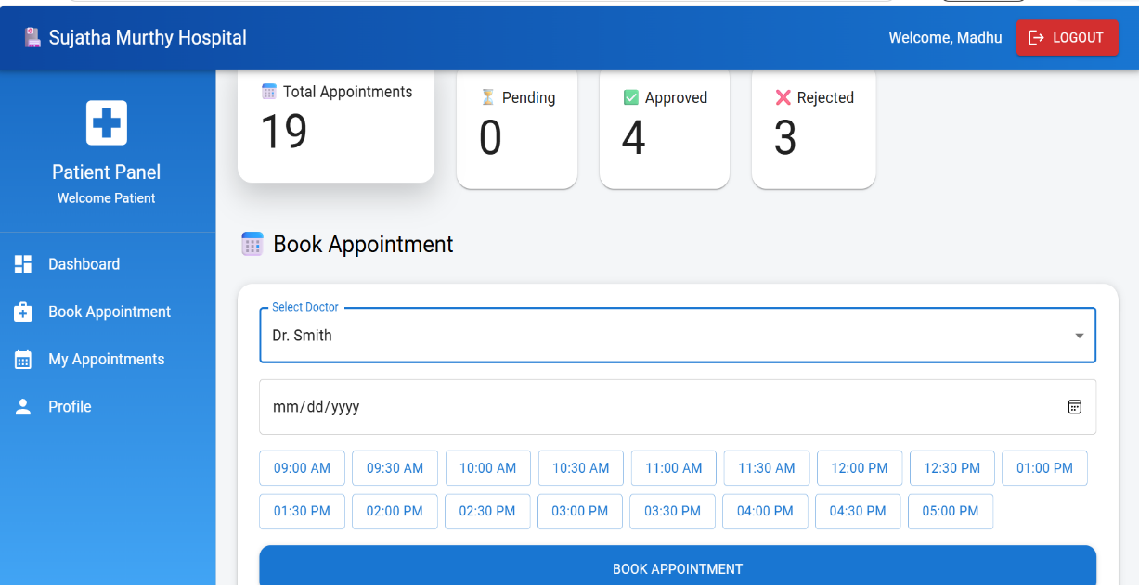
12. Known Issues

- No email notifications.
- Payment integration is not implemented.

13. Future Enhancements

- Online payment gateway
- Email/SMS notifications
- Video consultation
- Doctor ratings and reviews
- Mobile application support

